* **LOGIN UI**

Using Python, the Tkinter framework, and Sqlite3, a functional software was logically and methodically coded. The team members allocated the tasks based on their areas of expertise and interest. The Python programming language, Tkinter GUI tools, and Sqlite3 database were utilized by the team to create a completely functional application through coding. For ease of comprehension, the program can be separated into the following sections.

**STAFF LOGIN**

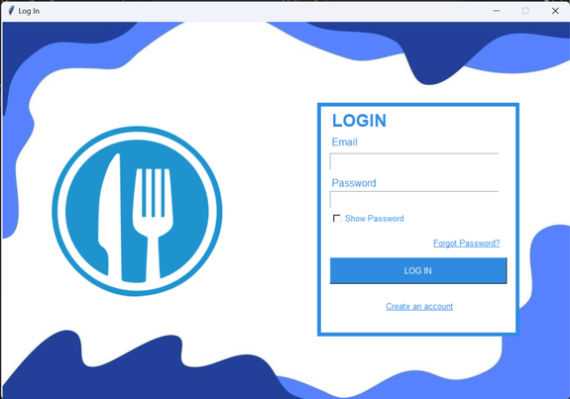

An employee's account can be safely accessed by a platform using the Login UI by using legitimate   
data. The employee goes to the website of the restaraunt and checks whether the employee has an account or they should “CREATE AN ACCOUNT”. The “EMAIL” and “PASSWORD” credentials are than filled after and employee is “REGISTERED” to the website with the user’s details. It enables superiors to modify their subordinates' information if they misplace their pin or to remove their account in the event that they quit. The "QUIT" button allows users to exit the software. When commands are executed, the message box pops appropriately. The "LOGOUT" button on the "STAFF LOGIN" page allows the logged-in manager to log out.